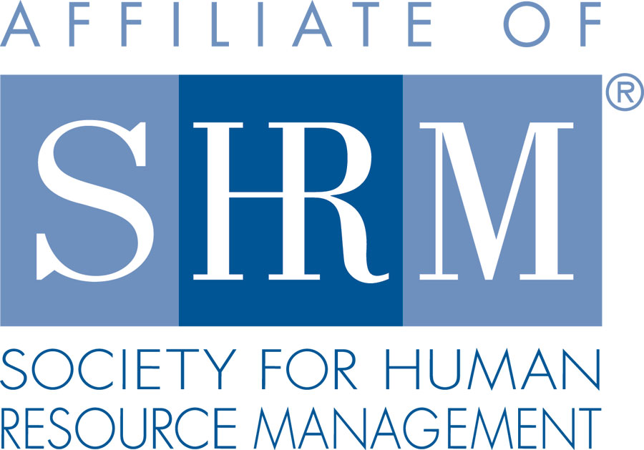

Scholarship Application

The Sauk Columbia SHRM will award up to four $750 scholarships annually to graduating seniors continuing their education at an accredited college, university or technical college on a full-time basis.

The scholarships are awarded based upon several factors, which may include: past academic performance, your application essay, personal need of the applicant and the overall strength of the application. Interested graduating seniors must submit the completed application to the Student Services Office by March 1st.

PERSONAL DATA

Name _________________________________________ Email Address _______________________

Address _______________________________________ Telephone # _________________________

City, State, Zip _______________________________________________________________________

EDUCATIONAL DATA (Please provide a current copy of your high school transcript. Applications without a current transcript will not be considered.)
HIGH SCHOOL | GRADUATION DATE | COUNSELOR’S NAME

COLLEGE/UNIVERSITY PROGRAM
NAME AND ADDRESS OF COLLEGE (S) | ACCEPTED FOR ADMISSION ?  ( ) YES, STARTING _______________  ( ) STILL APPLYING
WHAT FIELD OF STUDY DO YOU PLAN TO MAJOR IN? | WHAT PROFESSION OR VOCATION DO YOU PLAN TO FOLLOW AFTER COLLEGE?

GENERAL INFORMATION
Please attach a personal essay including your future goals and aspirations; how your educational and/or career objectives complement those plans; any extracurricular activities and/or community service; why financial support is important for you; and any special strengths, skills or qualifications. Incomplete applications, those without essays, or those without transcripts will NOT be considered.

APPLICANT’S SIGNATURE | DATE

